3.8.1 Search Activity – Selecting fields

Go to the Australian site:
http://pericles.ipaustralia.gov.au/ols/auspat/structuredSearchPage.do and search for the word hovercraft in the title field. .

Answer to Search Activity
You can select the required field from the dropdown list, as shown below.

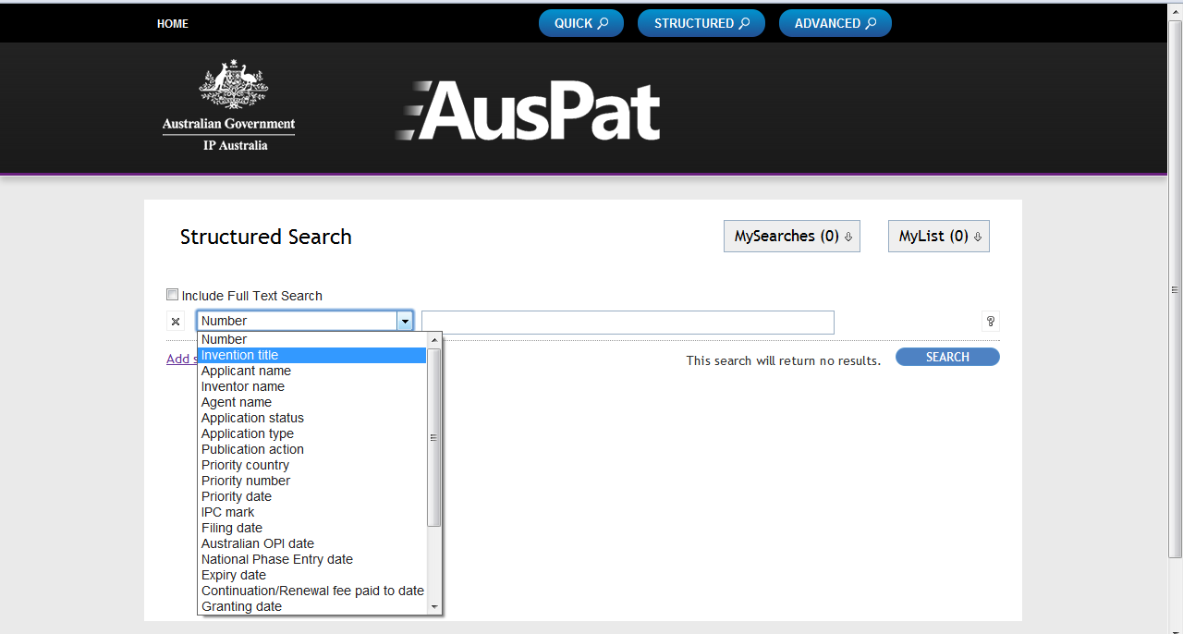

Enter ‘hovercraft’ and press ’Search’.

In Patentscope, on the ‘Advanced search’ page, you can select English title from the dropdown menu, the system will provide the field code, and you can type in ‘hovercraft’
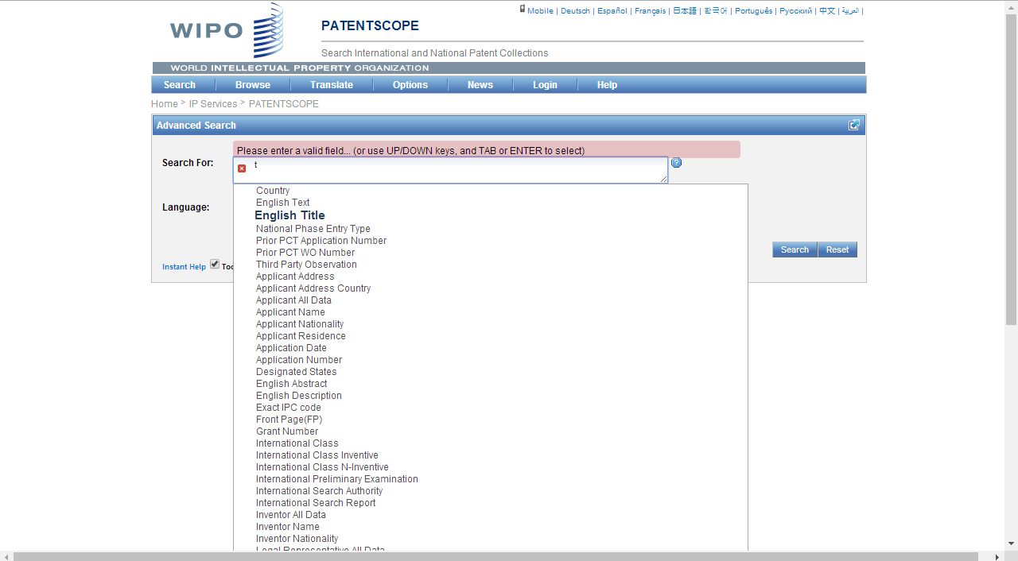

Alternatively, on the ‘Field Combination’ page, you can type in ‘hovercraft’ in the ‘English title’ box:
